Susan Phillips CSCI 325

Project Documentation: Connect 4

Rules of the Game:

* 2 players take turns dropping colored disks into the top of a seven-column, six-row vertical grid.
* Object of the game is to connect four of your colored disk either vertically, horizontally or diagonally.
* The 1st player to connect all four disks is the winner.

Connect 4 Game:

JFrame

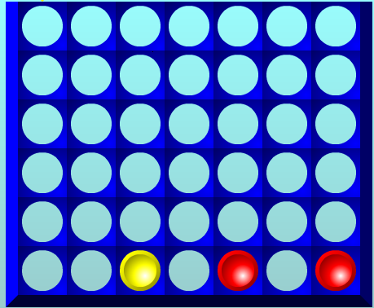

Player 2 (Yellow)

Player 1 (Red)